

**One of the applicable programs is:**

MusixMatch

# Project report content is:

1. **How does the program work and how does it work?**

Musixmatch uses the access permission to be able to read the transmission in the output and use that to search, identify the song, and provide the lyrics. Unlike apps like shazam that recognizes the song from the microphone, musixmatch directly hits the output because there is no interference to any noise and as a result finds the song with the lyrics faster and more accurate than its competitors.

# One of the algorithms applied is:

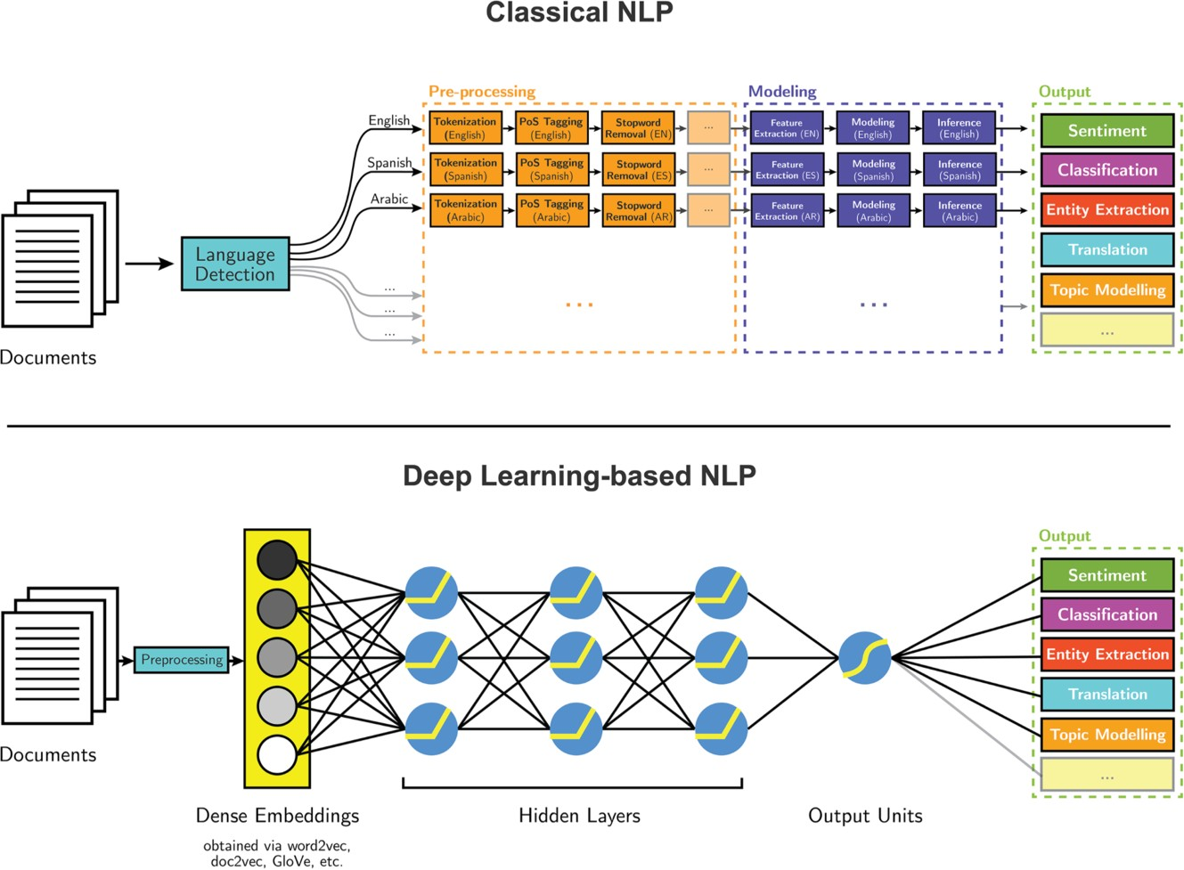

## Classical NLP:

A Classical NLP pipeline expects a language detection system as first step: the reason is that next steps can differ depending on it. After this detection, the *corresponding pipeline* of preprocessing steps is performed, which includes Tokenization, Part-Of-Speech tagger and Named Entity Recognition. Human-designed features come from the output of these preprocessing steps. Then a model can be created and the inference for the desired task executed.

## Deep Learning:

Deep Learning is based on a completely different approach. After an initial preprocessing of raw data, the input is embedded in *dense vectors*, which can be generated by different techniques like word2vec, GloVe and doc2vec. This becomes the new input of the neural network which feeds the hidden layers. Through these layers the network learns how to reach the goal of the task.

# Features in MusixMatch:

1. **Lyrics Search**

People most likely remember part of lyrics rather than the song title. Musixmatch will let you search by lyrics and enrich your search experience to feel just magical.

1. **Synchronized Lyrics**

Engage users with perfectly-synced lyrics, line by line or word by word.

Deliver new experiences on sing-along or contextual display to enrich the music experience.

1. **Translated Lyrics**

Lyrics translations break down language barriers and add meaning to music.

Combining time synchronization with lyrics translations Musixmatch is able to offer the ultimate experience for multi-lingual listeners.